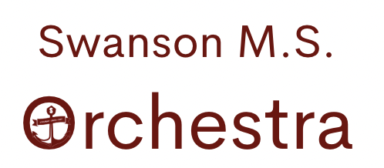
Orchestra Handbook 2023-2024
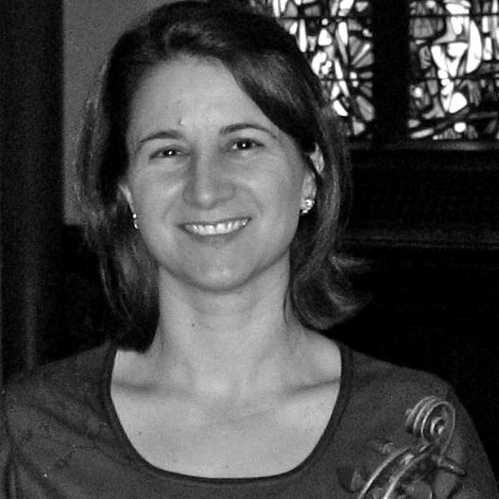
Caroline Levy
Orchestra Director
Swanson Middle School
caroline.levy@apsva.us
Course Overview

Welcome to the Swanson Orchestra! This year you will enhance your musical foundation through the study of orchestral performance. I take great pride in being a part of the orchestra program at Swanson and it is very important to me that you also take pride and enjoy our program. We all have the opportunity to put forth our best effort and get the most out of our time together in orchestra. It is my hope that this is just the beginning of your lifelong musical journey and that through orchestra you will:
- Advance your understanding of musical concepts
- Develop performance skills to play your instrument with a beautiful tone
- Improve music literacy
- Practice cooperation and self-discipline
Materials
REQUIRED:

- Instrument

  - ​Students must have a properly sized instrument to participate in the orchestra, and are encouraged to rent an instrument from a local music store (see list of local music stores).
  - There are a limited number of school instruments available to rent. Priority will be given to students who qualify for financial assistance.

  - Cello and Bass students may use a school instrument so that they don't need to bring their own instrument to school every day, but must have an instrument at home.
    - School instrument rental fee:
      - $100.00 – Standard rate
      - $25.00 – Free/Reduced Lunch rate

- Accessories:
  - Rosin
  - Violin/Viola: Shoulder Rest or Sponge
  - Cello/Bass: Endpin anchor
  - Music Stand
  - Metronome/Tuner
  - Pencil (provided in class)
  - Soft Cloth
*Please contact Ms. Levy about information pertaining to instrument rental or purchase from a local music store if you have any questions. It is recommended that students change the strings on their instrument and re-hair the bow before the start of each school year to keep their instrument in good playing condition.

Local Music Stores
Foxes Music Company  416 Washington St.  Falls Church, VA 22046  https://www.foxesmusic.com | Day Violins  14221A Willard Rd #500  Chantilly, VA 20151  https://www.dayviolins.com​
Brobst Violins  5584 General Washington Dr.  Alexandria, VA 22312  https://brobstviolinshop.com | Potters Violins  7711 Eastern Ave NW.  Takoma Park, MD 20912  https://potterviolins.com​
Online Music Shops

Shar Music  2465 South Industrial Hwy  Ann Arbor, MI 48104  1-800-248-7427  www.sharmusic.com | Johnson String Instrument  11 John Street  Newton Center, MA 02459  1-800-359-9351  www.johnsonstring.com | Southwest Strings  1721 S. Cherrybell Strav  Tucson AZ, 85713  1-800-528-3430  www.swstrings.com
It is not necessary to buy an instrument. In fact, I recommend that you rent an instrument until you are certain your child has made a long term commitment and is ready for a full-sized instrument. Your child must be measured by your teacher or at the music store to be fitted for the correct sized instrument.
If you are considering purchasing an instrument from another source, please contact me to assist you. EBAY and PAWNSHOPS are NOT reliable sources and often sell defective or simply unplayable instruments. The #1 reason students lose interest is due to an instrument of poor quality that is difficult and frustrating to play.

Grading Policy
Student grades reflect student achievement and not student behavior.

Rehearsal Technique (formative) | 20%
Tests, Quizzes and Assignments (formative) | 20%
Performances (summative) | 60%
Rehearsal Technique
Students will earn 10 points per week for their participation in class. Students earn points by having all their materials, coming to class on time, following appropriate rehearsal protocol, and playing their instrument with the orchestra. Students who are not able to play because of long fingernails or inappropriate clothing (cellists!) will not earn their weekly participation points.

Our classroom rules are as follows:
1. Listen and follow directions
2. Use hand signals
3. Stay on task
4. Keep your hands and feet to yourself
5. Respect your classmates, school, and teacher
Every time a classroom rule is broken, a consequence is given. Our classroom consequences are as follows:
1. Redirect (a verbal warning)
2. Side Line (break in a specific area in classroom)
3. Break and reflection time (in the hall or counseling room)
4. Letter Home (letter home to parent that must be signed and returned)

Quizzes and Tests
- Performance Test
​Performance tests will be held once per quarter and will be used to determine seating placements. Performance tests will include excerpts from the concert music. Tests are worth 20 points
- Fundamentals Quizzes
Fundamentals are instrumental skills learned during orchestra class and include left hand and right hand techniques. Students will practice fundamentals during class and will be assessed on these skills during class time. Each fundamentals playing quiz is worth 10 points.
- Music ​​Literacy Assignments
Students will be responsible for completing written music theory and literacy assignments. Literacy assignments will be explained during class but completed for homework. Each unit culminates with a written literacy quiz given during class time. Literacy quizzes are 20 points.

Performances
​Students are required to attend all concerts and dress rehearsals. Students should arrive on time and in concert attire to receive full credit. Be sure to mark all concert and rehearsal dates in your calendar well in advance, and let Ms. Levy know if you have an unavoidable conflict. An alternative assignment must be completed to receive credit if performances are missed.

Formal Concert Attire (Winter Concert, Assessment, Spring Concert)

- White Shirt
- Black dress pants or long black skirt (no leggings or jeans)
- Black dress shoes

Informal Concert Attire (In-school performances, Field Trips)

- Swanson Orchestra T-Shirt
- Jeans (no holes)
- Sneakers (no crocs)

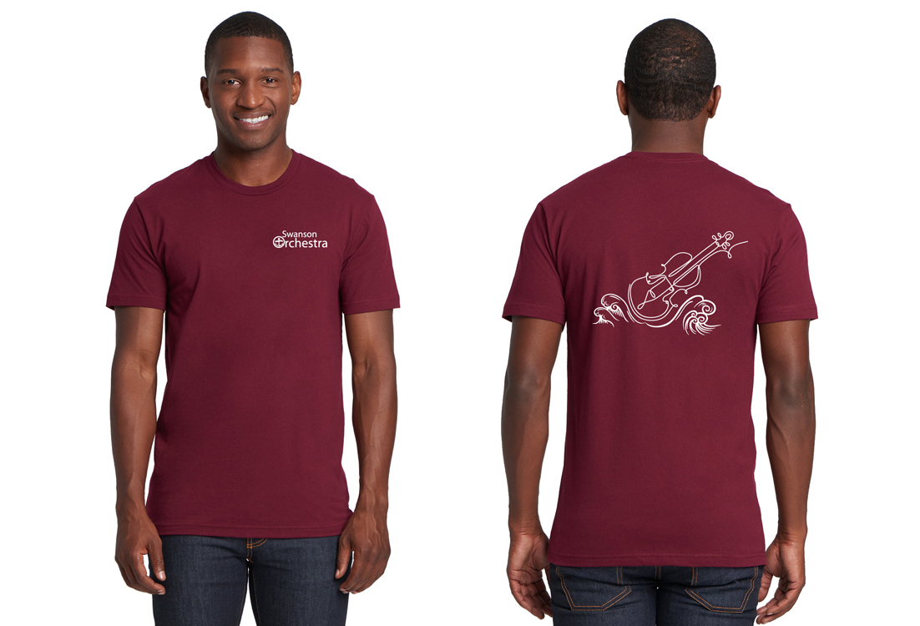

Swanson Orchestra Tee Shirts:
Available in sizes XS - XL
$11.00
If you need financial assistance please contact Ms. Levy

Field Trips
Each spring the orchestra tries to participate in Music at the Parks. This is an all day field trip to a Theme Park where students have the opportunity to perform as an orchestra for judges to receive a rating and feedback. Students will also have time to enjoy the park with their friends. More information about this will be coming soon. Parents chaperones are needed for this trip so save the date!
Private Lessons
Students who enjoy their instruments and who are interested in improving their performance may consider taking private lessons. Private instructors teach one on one, at the student's pace, and help each student develop technical and musical skills specific to their instruments. These skills can be well applied in an orchestra setting, and in most cases, students who work with a private instructor progress much faster than those who do not. Teacher fees vary and are generally between $60 to $100 an hour. Lesson lengths may also vary - 30 mins is recommended for 6th grade, 45 minutes is recommended for 7th/8th grade. If you are interested in getting instruction see the PRIVATE TEACHER LIST.

APS Junior Honors Orchestra
This is an honor orchestra for APS students in 4th - 6th grade by audition. Students accepted into this ensemble rehearse weekly from January through March and perform in the honors concert. The audition for Junior Honors Orchestra will be held on Wednesday, Nov. 8. More information can be found on the Orchestra Canvas pages.

APS Honors Orchestra
This is an honor orchestra for APS students in 7th - 8th grade by audition. Students accepted into this ensemble rehearse Jan. 24-27 in the evening and perform in an honors concert on Saturday, Jan. 27. The audition for Junior Honors Orchestra will be held on Wed, Nov. 8. More information can be found on the Orchestra Canvas pages

Junior District Honors Orchestra
Junior District Honors Orchestra (JDHO) auditions will take place on Tuesday, November 14th. The Junior District Honors Orchestra Event will be held Friday – Saturday January 12-13, 2024. Students in grades 7-8 interested in auditioning for JDHO must apply. Applications and fees will be due on or about September 16, 2023.

Solo and Ensemble Festival
Solo and Ensemble Festival will be held Fri-Sat, Apr 19-20 at Carson Middle School this year. Students who would like to participate prepare a solo or ensemble piece to perform for a judge who will give feedback and a rating. Students who are interested should register and pay the fee on or about March 1, 2024.
2023-2024 EVENT CALENDAR
Dates in Bold are Required Attendance

Fri. Oct. 27, 6:00 pm Halloween Concert
Fri. Oct. 27, 7:00-9:00 pm Masquerade Party (Band, Choral and Orchestra Students) - SMS Cafeteria
Wed, Nov. 8, 4:30-7:30pm APS Honor Orchestra Auditions - Kenmore MS*
Tues, Nov. 14 Jr. District Honors Orchestra Auditions - Thoreau MS* (7 & 8th grade only)
Weds. Dec 13, 7:00pm Winter Orchestra Concert
Tues, Jan. 9 - Mar. 12 APS Jr. Honors Orchestra - Kenmore MS*
Fri-Sat, Jan 12-13 Jr. District Honors Orchestra Event - Langley HS*
Wed-Fri, Jan 24-27 APS Honor Orchestra Rehearsals - Kenmore MS*
Sat, Jan 27, APS Honor Orchestra Concert - Kenmore MS*
Tues, Feb 13, 7:00pm Orchestra Pyramid Concert - YHS
Fri-Sat, Apr 19-20, District 12 Solo and Ensemble Festival - Carson MS*
Fri-Sat, Mar, 8-9, TBD Middle School Orchestra Assessment - Kenmore MS
Sat. May 4 Possible Spring Trip for Prelude Ensemble
Sat. May 11 Possible Spring Trip for Admiral’s Orchestra
Weds. May 29, 7:00pm Spring Orchestra Concert

Swanson Orchestra Agreement

Reminder!
​Students are required to attend all concerts and dress rehearsals. Students should arrive on time and in concert attire to receive full credit. Be sure to mark all concert and rehearsal dates in your calendar well in advance, and let Ms. Levy know if you have an unavoidable conflict. An alternative assignment must be completed to receive credit if performances are missed.
____________________________________________________________________________
I confirm that:
- I have read and understand the policies stated in the Orchestra Handbook.
- I agree to comply with the class rules, procedures and expectations.
- I have a calendar of this year’s orchestra events. I understand that scheduled events may be changed as this year progresses, and safety/health will be the priority. Parents will be notified immediately of any changes.
- I understand the financial obligation to the orchestra program. No student will be denied participation due to financial concerns. Contact Ms. Levy for assistance.

Student Name _______________________________________

Student Signature _______________________________________
Parent/Guardian Name _______________________________________

Parent/Guardian Signature __________________________________

