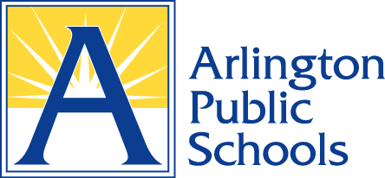VA

RISK MANAGEMENT, FACILITIES & OPERATIONS

2770 South Taylor Street • Arlington, VA 22206 • Phone: (703) 228-6600 Fax: (703) 671-2959

Arlington

Public

Schools

Dear Parent/Legal Guardian,

Arlington Public Schools values the relationship we have with all our parents and legal guardians. To ensure that the relationship between APS and you as a parent/legal guardian is understood as it relates to an accident that may occur while your student is at school or participating in a school activity is important for you to read the following information.

APS does not provide accident insurance to cover the medical cost associated with injuries your student(s) may sustain during the school day or while participating in school sponsored activities. We highly recommend that all parents and legal guardians consider participating in our optional student accident insurance program. This program is not just for students who do not have health insurance; optional student accident insurance may serve as a secondary coverage for those students who already are covered under a parent/legal guardian’s primary medical insurance plan. In some cases, the optional student accident insurance may cover expenses that are not paid for by the primary insurance plan, such as co-pays and other out of pocket costs.

We highly encourage all families in Arlington County to participate. This year’s program provides a group rate between $9 to $154 a student for the entire school year, depending on the coverage you select. Parents may enroll students through an online portal or by calling the number identified below for the Young Group, Inc. Enrolling online can be accomplished by using the dedicated secure enrollment site. Parents/legal guardians may enroll their student(s) now for policy coverage beginning August 25th, 2025, through June 18th, 2026.

For more information or to enroll in the plan offered by the Young Group, Inc. call 1-888-574-6288 or 1-919-9798 or visit [https://www.k12studentinsurance.com](https://www.k12studentinsurance.com/).

If students do not have medical insurance coverage in the event of an illness or injury, coverage is available to families through the Family Access to Medical Insurance Security (FAMIS) program. FAMIS is available to families who meet certain income and other eligibility requirements. The program is sponsored by the Commonwealth of Virginia. Information about FAMIS and enrollment forms are available online at https://coverva.dmas.virginia.gov/ or by calling 1-855-242-8282.

Sincerely,

Kyle Lorentson, M.Ed.

Risk Manager, Facilities & Operations