Talk About Books
Fall 2017 Book List

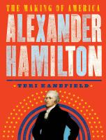  Alexander Hamilton: The Making of America  By Teri Kanefield  Alexander Hamilton envisioned a multiracial, urbanized, capitalistic America with a strong central government.. Here is the story that epitomizes the American dream--a poor immigrant who made good in America | 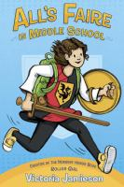  All's Faire in Middle School  By Victoria Jamieson  Homeschooled by Renaissance Fair enthusiasts, eleven-year-old Imogene has a hard time fitting in when her wish to enroll in public school is granted.
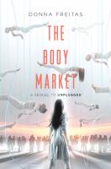  The Body Market  By Donna Freitas  Skylar Cruz found her sister in the Real World--only to learn that her sister has betrayed her and put everyone in the App World in danger. Shaken by the betrayal of everyone she trusted, Skylar is through being a pawn. She may be the only one who can stop what her family started. And she has to do it before the App World runs out of time. | Braced  By Alyson Gerber  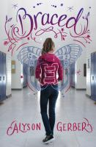  When twelve-year-old Rachel learns that her scoliosis has worsened and she'll need to wear a back brace to keep her spine straight, she's devastated, afraid that she won't be able to play soccer, and terrified that she won't be able to hide her condition from her friends and classmates.
Brave  By Svetlana Chmakova  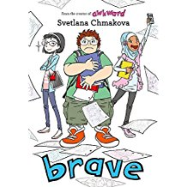  In his daydreams, Jensen is the biggest hero that ever was, saving the world and his friends on a daily basis. But his middle school reality is very different. The pressure's on once Jenny and Akilah draw Jensen into the whirlwind of school news, social experiment projects, and behind-the-scenes club drama | 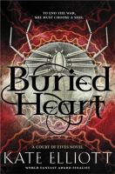  Buried Heart  By Kate Elliot  Jessamy is at the crux of a revolution forged by the Commoner class hoping to overthrow their longtime Patron overlords, but when enemies from foreign lands attack the kingdom, she must find a way to defend their home and all the people she loves.
Come on In, America: The United States in World WarI  By Linda Barrett Osborne  Come On In, America explores not only how and why the United States joined World War I, but also the events--at home and overseas--that changed the course of American history.  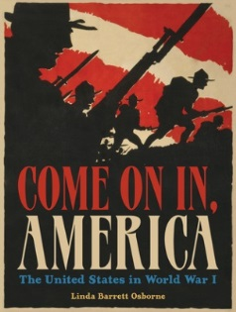 | A Dog in the Cave: The Wolves Who Made Us Human  By Kay Frydenborg  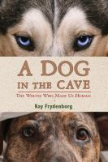  Fossil evidence shows that we began sharing our lives with dogs much earlier than had been previously thought. With this evidence, a new theory of human and dog coevolution has arisen, and with it a different way to look at our relationship with humankind's best friend.
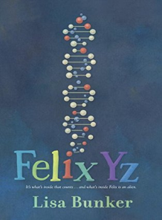  Felix Yz  By Lisa Bunker  Thirteen-year-old Felix Yz chronicles the final month before an experimental procedure meant to separate him from the fourth-dimensional creature, Zyx, with whom he was accidentally fused as a young child. | Finding Mighty  By Sheela Chari  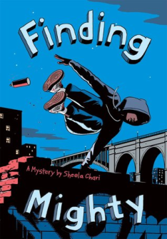  Neighbors Myla and Peter search for the link between Myla's necklace and the disappearance of Peter's brother Randall. Can Myla and Peter find Randall before it's too late, and their shared family secrets threaten to destroy them all?
The First Rule of Punk  By Celia C. Perez  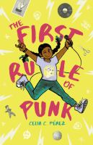  Roller Girl" meets "School of Rock" in this illustrated novel about identity, friendship, and riot-grrrl power by librarian and debut author Prez. | Fish Girl  By Donna Jo Napoli and David Wiesner  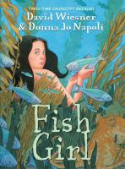  David Wiesner's first graphic novel, with text by acclaimed author Donna Jo Napoli, is a beautiful, engaging, and frequently funny coming-of-age tale about a mermaid for middle grade readers.
Funny Girl: Funniest. Stories. Ever.  By Betsy Bird  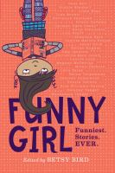  A collection of humorous stories from over two dozen contemporary female writers, as well as autobiographical essays, comics, poems, and comic strips. | Girl Code: Gaming, Going Viral, and Getting It Done  By Andrea Gonzales and Sophie Houser  The teenage phenoms behind viral video game Tampon Run share the story of their experience at Girls Who Code and their rise to fame, plus a savvy look at starts-ups, women in tech, and the power of coding. This book includes bonus content to help you get started coding.  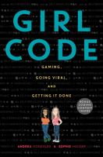
Horizon  By Scott Westerfeld  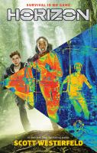  When a plane crash-lands in the arctic, eight young survivors step from the wreckage expecting to see nothing but ice and snow. Instead they find themselves lost in a strange jungle with no way to get home and little hope of rescue. | In Darkling Wood  By Emma Carroll  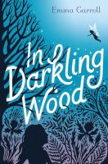  When Alice is suddenly bundled off to her estranged grandmother Nell’s house, there’s nothing good about it, except the beautiful Darkling Wood—Alice feels at home there. She even finds a friend, Flo. When Flo shows Alice the surprising secrets of Darkling Wood, Alice starts to wonder: What is real? And can she find out in time to save the wood from destruction? (Amazon)
In the Shadow of the Sun  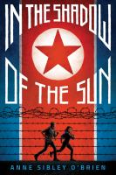  By Anne Sibley O’Brien  Twelve-year-old Mia is on a tour of North Korea with her older brother and their father, , but she is scared because her father keeps sneaking off at night. Things get much worse when she is pulled into a deadly political game that seeks to expose North Korean atrocities, and her father is arrested. | The Lost Kingdom of Bamarre  By Gail Carson Levine  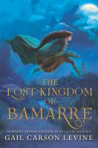  When visited by a fairy, fifteen-year-old Peregrine learns she is not Latki-born, so she begins to free her people from tyranny, even if it means fighting monsters--both magical and human.
The Lotterys Plus One  By Emma Donoghue and Caroline Hadilaksono  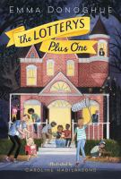  Once upon a time, two couples won the lottery and bought a big house where all of them could live together in harmony--but change is inevitable, especially when a disagreeable grandfather comes to stay. | Lumberjanes Band Together  By Shannon Watters, Noelle Stevenson, Grace Ellis, and Brooke Allen  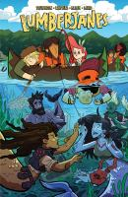  The story follows a group of girls named Mal, Ripley, Molly, April, and Jo spending summer at a scout camp, and the strange creatures and supernatural phenomena they encounter there.
Mango Delight  By Fracaswell Hyman and Frank Morrison  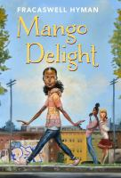  What happens when your BFF becomes your EFF . . . EX-Friend-Forever? Surviving seventh grade is tough-especially when your BFF dumps you, you lose your spot on the track team, and you cost your dad his job. THEN Mango becomes a YouTube sensation, and attracts the attention of the school's queen bee. Soon Mango is forced to make tough choices about the kind of friend she wants to have . . . and the kind she wants to be. | Patina  By Jason Reynolds  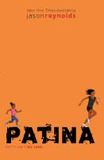  A newbie to the track team, Patina must learn to rely on her teammates as she tries to outrun her personal demons in this follow-up to the National Book Award finalist "Ghost.”
Posted  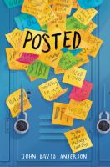  By John David Anderson  When cell phones are banned at their school, students start communicating through sticky notes left all over the school, triggering a wave of bullying activities in the wake of a new girl's arrival. | Queer, There, and Everywhere: 23 People Who Changed the World  By Sarah Prager and Zoe More  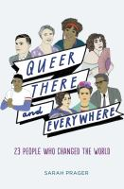  World history has been made by countless lesbian, gay, bisexual, transgender, and queer individuals--and you've never heard of many of them. Prager delves deep into the lives of 23 people who fought, created, and loved on their own terms.
Quicksand Pond  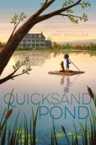  By Janet Taylor Lisle  Twelve-year-old Jessie spends the summer with her family on Quicksand Pond, a New England vacation spot, where she develops a star-crossed friendship with independent Terri, and meets a reclusive old lady whose connection to a murder that took place decades ago still informs her present. | Real Friends  By Shannon Hale and LeUyen Pham  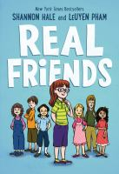  Newbery Honor author Shannon Hale and New York Times bestselling illustrator LeUyen Pham join forces in this graphic memoir about how hard it is to find your real friends and why it's worth the journey.
Refugee  By Alan Gratz  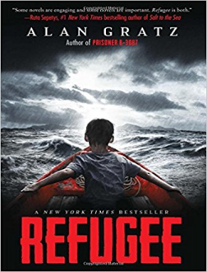  Although separated by continents and decades, Josef, a Jewish boy living in 1930s Nazi Germany; Isabel, a Cuban girl trying to escape the riots and unrest plaguing her country in 1994; and Mahmoud, a Syrian boy in 2015 whose homeland is torn apart by violence and destruction, embark on harrowing journeys in search of refuge, discovering shocking connections that tie their stories together. | Restart  By Gordon Korman  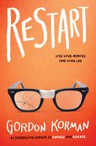  Chase doesn't remember falling off the roof; in fact, he doesn't remember anything about himself, and when he gets back to middle school he begins to learn who he was through the reactions of the other kids. Trouble is, he really isn't sure he likes the Chase that's being revealed, but can he take the opportunity amnesia has provided and restart his life?
Solo  By Alexander Kwame and Mary Rand Hess  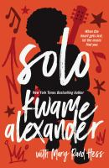  From award-winning and bestselling author Kwame Alexander comes Solo, the story of seventeen-year-old Blade Morrison who is being crushed between the scathing tabloids exposing his former rock-star-father's addictions and a protected secret that threatens his own identity. The answers to his past and future change everything he thought to be true. | Soupy Leaves Home  By Cecil Castellucci and Jose Pimienta  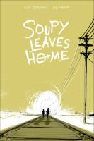  When Pearl runs away from her abusive father, she has nowhere to go--until she stumbles upon a disguise that gives her the key to a new identity. Reborn as a boy named Soupy, she hitches her star to Ramshackle, a hobo who takes her under his wing.
Star-Crossed  By Barbara Dee  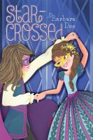  When Mattie's cast as Romeo in an eighth-grade play, she's confused to find herself increasingly attracted to Gemma, a new classmate who's playing Juliet. | Ten: A Soccer Story  By Shamini Flint  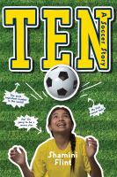  In Malaysia in 1986, soccer is "a boys' game," but ardent soccer fan Maya trains herself in soccer skills and pulls together a team at her (girls') school. Despite all odds, she wins not just an important game but a chance to go to England and watch her favorite pro team play-and incidentally make an unsuccessful attempt to pressure her dad into rejoining the family.
This Is Just a Test  By Wendy Wan-Long, Shang and Madelyn Rosenberg  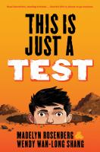  In 1983 seventh-grader David Da-Wei Horowitz has a lot to worry about--his bar mitzvah's coming soon, his Jewish and Chinese grandmothers argue about everything, his teammates for the upcoming trivia contest, Scott and Hector, don't like each other, he's beginning to notice girls, and Scott's persuaded him to begin digging a fallout shelter just in case the Cold War heats up. | Train I Ride  By Paul Mosier  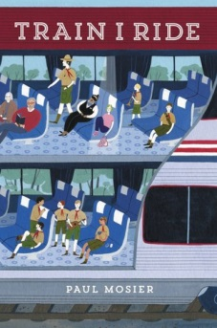  Traveling from California to Chicago after her mother dies of a drug overdose and her grandmother of lung cancer, thirteen-year-old Rydr meets other passengers on the train and attempts to accept her own situation.
The Trials of Apollo, Book Two: The Dark Prophecy  By Rick Riordan  Zeus has punished his son Apollo by casting him down to earth in the form of a gawky, acne-covered sixteen-year-old mortal named Lester. The only way Apollo can reclaim his rightful place on Mount Olympus is by restoring several Oracles that have gone dark. What is affecting the Oracles, and how can Apollo/Lester do anything about them without his powers?  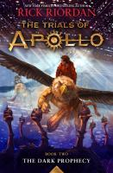 | Us, in Progress: Short Stories about Young Latinos  By Lulu Delacre  In this book, you will meet many young Latinos living in the United States, from a young girl whose day at her father's burrito truck surprises her to two sisters working together to change the older sister's immigration status, and more.  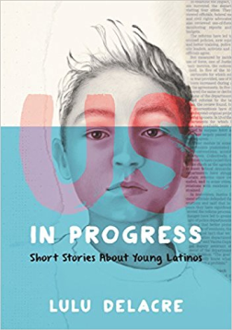
York: The Shadow Cipher  By Laura Ruby and Dave Stevenson  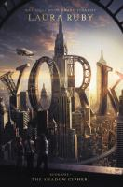  In an alternate history of New York, three kids try to solve a modern-world puzzle and complete a treasure hunt laid into the streets and buildings of the city. | *Images from goodreads.com. Desciprtions adapted from Ingram, except where noted otherwise.

